6th ANNUAL F-M MARCH MADNESS 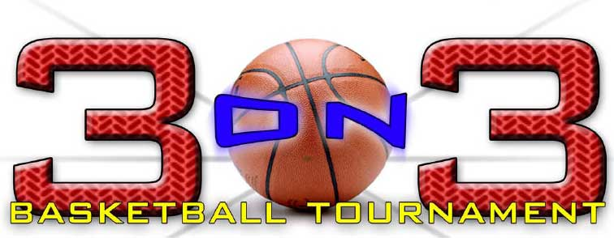
Friday, March 24, 2017, 5PM-9PM
Saturday, March 25, 2017, 8AM-5PM
@ F-M High School
Registration Form

TEAM NAME:_________________________ MALE □ FEMALE □

DIVISION: Gr3/4 □ Gr5/6 □ Gr7/8 □ Gr9/10 □ Gr11/12 □ Adult □
(subject to change based on teams enrolled, captain will be notified of any changes in advance)
Team Captain Name & Contact #: _____________________________________
Team Captain Email: ___________________________________________________
Player Name Player Grade

1._______________________________________ ____________

2._______________________________________ ____________

3._______________________________________ ____________

4._______________________________________ ____________

Each player must complete the Liability and Release Waiver Form. No one can participate without one completed.

□ Check here if all participants have read the tournament rules and will comply with them.

Complete and mail form, check and wavier to: Sam Elbadawi, 7616 Hunt Lane, Fayetteville, NY 13066. Questions- call Sam at 575-6121
(Make checks payable to: F-M All Sports Booster Club or FMASBC)

Registration Deadline March 15, 2017
Space is limited to first 70 teams

Sponsored by the F-M All Sports Booster Club

6th ANNUAL F-M MARCH MADNESS
Friday, March 24, 2017, 5PM-9PM
Saturday, March 25, 2017, 8AM-5PM
@ F-M High School

Liability Release and Waiver Form (1 of 2)
This form must be completed and signed by each player (or parent or guardian for participants under 18 years of age). By signing this Liability and Media Release and Waiver (“Waiver”), the individual named
below wishes to participate in the event described below and recognizes that there are
risks of damage or injury arising from participation in this event or from other activities
(including travel) that may be associated with participation in this event.
Event: F-M March Madness 3 on 3 Basketball Tournament Event Date: March 24 & 25, 2017
By his/her signature below, or by the signature of the participant’s parent/guardian, the
participating individual voluntarily agrees to assume and/or incurs all risks of loss,
impairment, damage or injury or whatever kind, including death, that may be sustained
or suffered by participation in this event whether or not the result in whole or in part of
the acts or omissions, negligence, or other unintentional fault of the event sponsors or
property owners. In addition, the participant (including his/her heirs, assigns and
personal representatives) agrees to release, hold harmless, and indemnify, The F-M 3
on 3 committee, F-M All Sports Booster Club, organizers, volunteers and sponsors from and against any claims, demands, actions, causes of action, lawsuits, expenses or losses (including attorneys’
fees) on account of property damage or personal injury (including death) arising out of
or attribute to the individual’s travel to or participating in the event.
By his/her signature below, or by the signature of the participant’s parent/guardian, the
participating individual voluntarily waives all rights of ownership to any written,
photographic or video use (whether in written or electronic form) of the participating
individual’s name, image or representation (“Data”), and hereby grants permission for
the publication, announcement and/or distribution of said Data thereof by F-M 3 on 3
Committee and it’s media.
This Assumption of Risk and Waiver release applies to the Organizers, The F-M 3 on
3 Committee, and all of their trustees, officers, directors, managers, servants, agents,
staff, volunteers, employees, advisors and/or representatives.
In the event that a tournament player breaks or damages a basketball backboard, pole,
rim or net the player and/or his parent/ guardian are responsible for monetary
replacement of the damaged equipment. Slam dunking in this tournament is strictly
prohibited.

Liability Release and Waiver Form (2 of 2)
Player (1)
The undersigned acknowledges that he/she has read and understands this document and that no changes will be made to this document.
Executed as of this ______________ day of _____________ 2015
Participant’s Name:__________________________________
Address:__________________________________________
_________________________________________________
Email:____________________________________________
Phone Number(_____)________________
Team Name:_______________________________________ Team Division_________
Participant’s Signature or Parent/Guardian:_____________________________________
Parent or Guardian Signature is required if participant is under 18 years of age

Player (2)
The undersigned acknowledges that he/she has read and understands this document and that no changes will be made to this document.
Executed as of this ______________ day of _____________ 2015
Participant’s Name:__________________________________
Address:__________________________________________
_________________________________________________
Email:____________________________________________
Phone Number(_____)________________
Team Name:_______________________________________ Team Division_________
Participant’s Signature or Parent/Guardian:_____________________________________
Parent or Guardian Signature is required if participant is under 18 years of age

Player (3)
The undersigned acknowledges that he/she has read and understands this document and that no changes will be made to this document.
Executed as of this ______________ day of _____________ 2015
Participant’s Name:__________________________________
Address:__________________________________________
_________________________________________________
Email:____________________________________________
Phone Number(_____)________________
Team Name:_______________________________________ Team Division_________
Participant’s Signature or Parent/Guardian:_____________________________________
Parent or Guardian Signature is required if participant is under 18 years of age

Player (4)
The undersigned acknowledges that he/she has read and understands this document and that no changes will be made to this document.
Executed as of this ______________ day of _____________ 2015
Participant’s Name:__________________________________
Address:__________________________________________
_________________________________________________
Email:____________________________________________
Phone Number(_____)________________
Team Name:_______________________________________ Team Division_________
Participant’s Signature or Parent/Guardian:_____________________________________
Parent or Guardian Signature is required if participant is under 18 years of age

